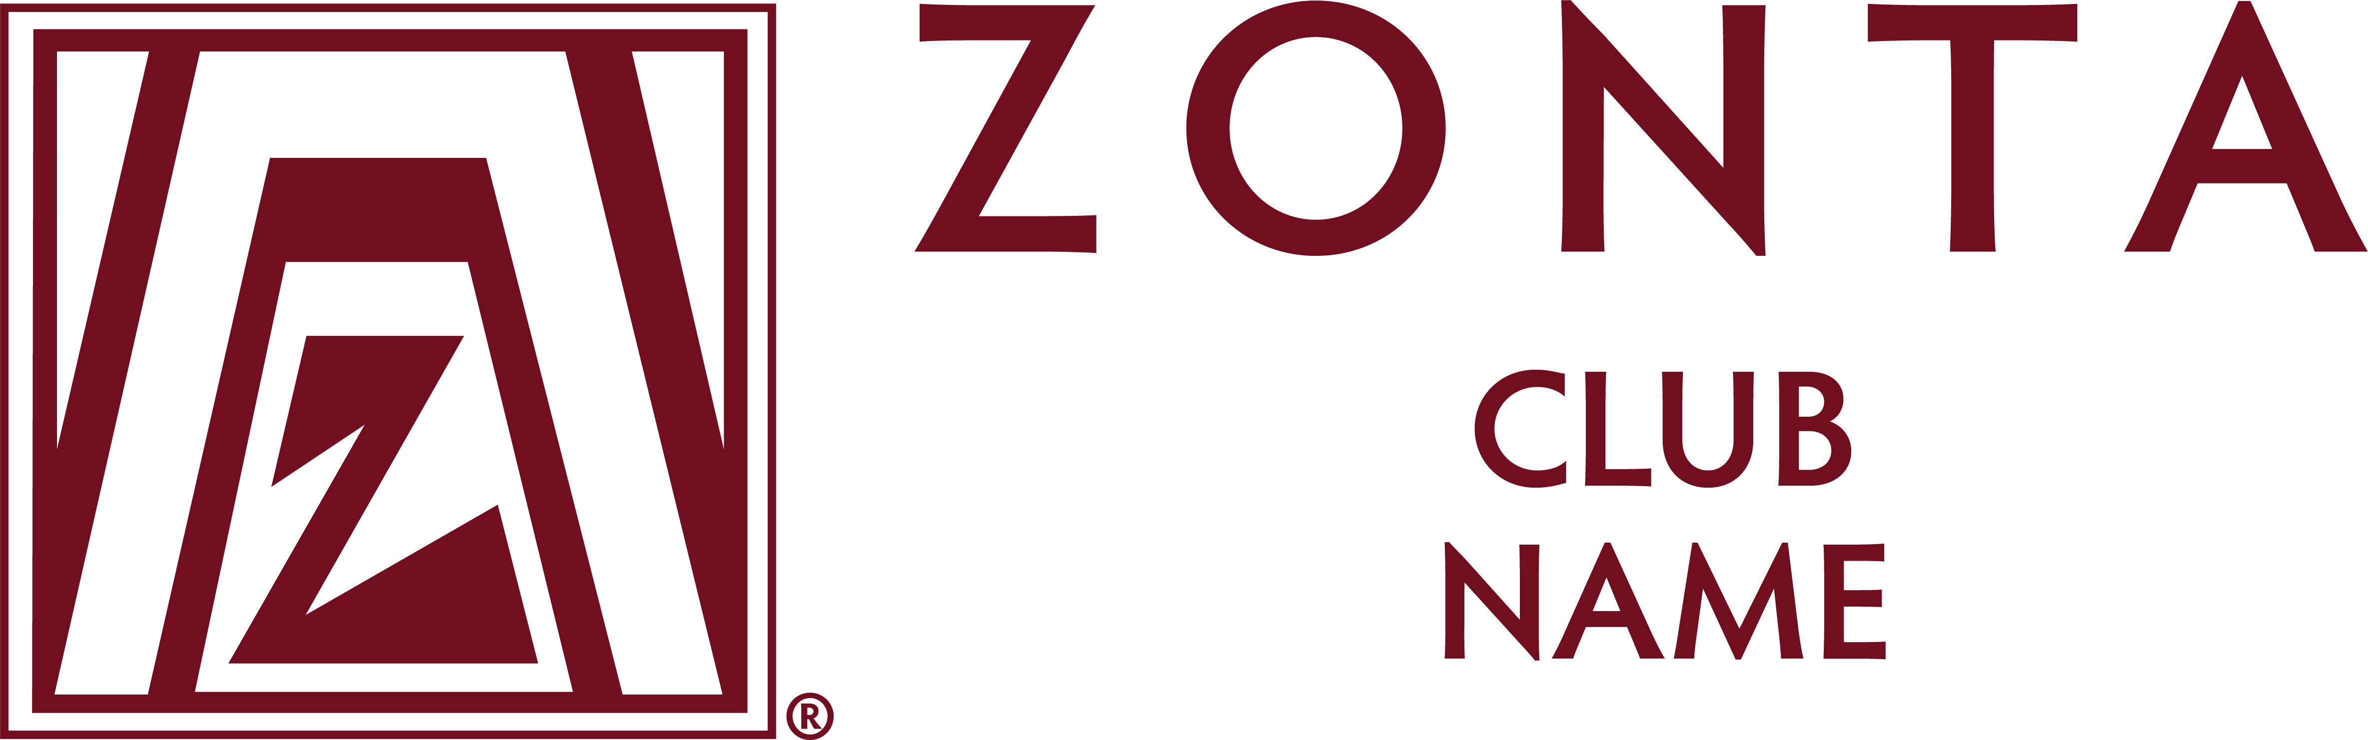

NEWS RELEASE
For more information contact:
Day Phone:
Night Phone:

For Immediate Release

Zonta (District # or Zonta Club of)
Zonta Young Women in Leadership Award Applications Available

Anytown, AnyState, Today’s Date…Applications for the 2025 Zonta Young Women in Leadership Award are now available from the Zonta [Club / District] by contacting: [add contact information].

The goal of the Zonta Young Women in Leadership Award is to encourage young women to participate in leadership positions by recognizing a young woman’s commitment to the volunteer sector, evidence of volunteer leadership achievements and dedication to building a better world for women in girls.

Applicants are asked to reflect on their voluntary commitment to their school and to their community and the problems limiting the empowerment of women in their own country and worldwide. The Zonta Young Women in Leadership Award looks to the young women of today to be the leaders of tomorrow.

Applications are due to: [insert information] by [insert deadline]. Applicants aged 16-19 on 1st April each year, studying at a secondary school, college or university in a Zonta district, or who are studying elsewhere but are citizens of a Zonta country at the time of application, are eligible to apply. The application process must start with a Zonta club and applicants may use the Club Locator on the Zonta International website, www.zonta.org, to locate the nearest Zonta club. Please contact the Zonta club for deadline information. Note that applicants from geographic areas within a Zonta district where no clubs are located may apply via a Zonta e-club or directly to the district to be eligible for the international awards.

Insert paragraph about your Zonta club or district

Zonta International, with world headquarters in Oak Brook, IL, USA, is a leading global organization of individuals working together to build a better world for women and girls. The Zonta Young Women in Leadership Award is one of many programs for women and girls sponsored by Zonta International. The Award is funded by voluntary contributions to the Zonta Foundation for Women Zonta Young Women in Leadership Award Fund.
Address | City | State | Country | Phone | Fax
Web address | Email address
# # #

